**Why do we need an Attendance Management System ?**

We have an Attendance machine which gives us data in the form of a log/csv file. It is difficult to get reports out of it and we need to calculate the count of attendance everytime we need to. Hence we need a system where anyone can see the tenant’s attendance online and generate reports.

**Requirements and goal of the system (Phase 1)**

Our system should meet the following requirement :

**Functional Requirements**

1. Users should be able to upload the file received from the Attendance Machine/Sewa Samiti and the system should process the attendance and save data in respective tables.
2. System should be able to detect the errors in the file and report back.
3. System should save the file in the s3/drive/dropbox etc and should delete after the configured time.
4. API to add/update/delete the attendance of users.
5. API to list down the attendance of users in a particular tenant based on filters.
6. System should be able to generate emails. (Kedar)

**Non Functional Requirements**

1. Data should not take much time to process and in case of any error ,user should be reported with the errors in the file.

**Extended Requirements**

1. How much time a file is taking to process based on the size and how many times a user uploads a file monthly/yearly etc.

**Load in the system**

Our system will be read heavy as attendance data will be processed probably once in a month or may be in a longer time period.

**Database Design**

**Terminology used**

RFID : It's a unique batch id written on the back of the card.

1. **sewadaar_attendace_summary** : Contains the final summary of attendance records.

| user_attendance_records | |
| --- | --- |
| id | GUID |
| sewadaar_id | String |
| department_id | String |
| badge_no | String(Unique but can be nullable) |
| month | Integer |
| year | Integer ( default current year) |
| weekdays | Integer |
| sundays | Integer |
| hash_value | String (To identify the uniqueness) |
| audit_log_id | Integer |

1. **uploaded_file_details :** Contains details of file being uploaded

| uploaded_file_details | |
| --- | --- |
| id | Integer |
| file_path | String |
| file_hash | String |
| platform | s3/drive/dropbox |
| audit_log_id | Integer |

1. **attendace_process_status :** Once file is uploaded and initial checks are done , we will start the asynch process.

| attendace_process_status | |
| --- | --- |
| id | Integer |
| uploaded_file_details_id | FK to uploaded_file_details |
| status | UPLOADED/IN_PROCESS/PARTIAL_SUCCESS/FAILED |
| validation_errors | List of validation errors |
| pending_records_file_path | FK to uploaded_file_details |
| audit_log_id | Integer |
| process_start | datetime |
| process_end_time | datetime |

File_hash : Unique file to be uploaded always.

Pending_records_file_path : Error records will be copied to this file and given to user.

1. **sewadaar_attendace_summary_archive** : Contains the archived data.

| sewadaar_attendace_summary_archive | |
| --- | --- |
| id | GUID |
| sewadaar_id | String |
| department_id | String |
| badge_no | String(Unique but can be nullable) |
| month | Integer |
| year | Integer ( default current year) |
| weekdays | Integer |
| sundays | Integer |
| audit_log_id | Integer |

**To be decided**

**csv_validations** : Contains validations to be done on CSV. What if a certain tenant does not want a few validations to be active ?

| csv_validations | |
| --- | --- |
| id | GUID |
| validation_name | String |
| validation_class | String |
| tenant_id | FK |
| is_active | Boolean |

**Suggested design**

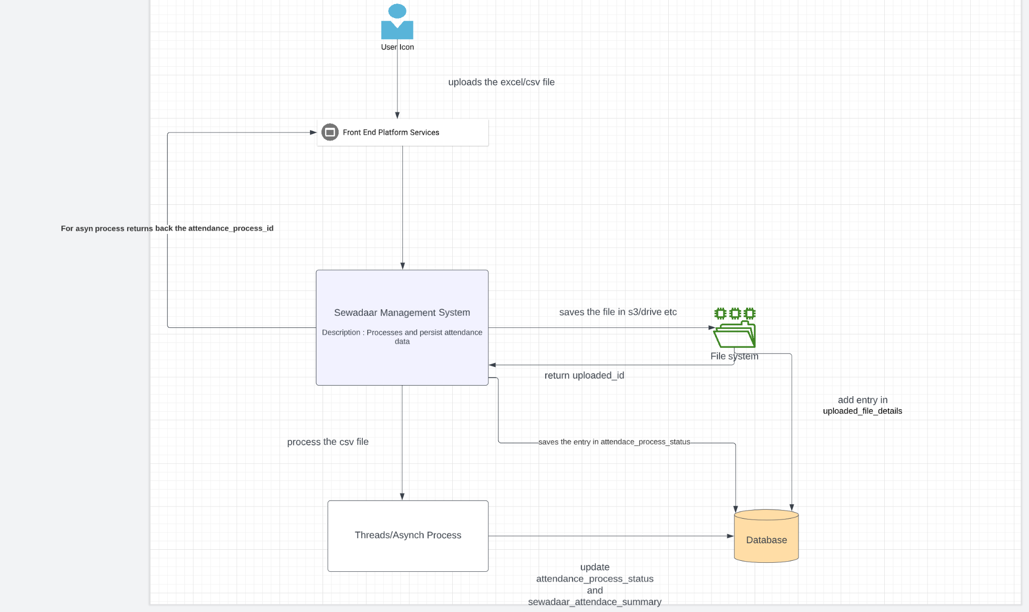

1. Once user uploads the file , System saves the file in s3/drive and add an entry in upload_file_details.
2. System add an entry in attendance_process_status and starts async process. If there are validation errors , system updates the attendance_process_status with errors.
3. If there are no errors in the file , system process the file and saves the data in sewadaar_attendace_summary and update attendance_process_status.
4. Records not being saved will be added to another csv file so that user need not to manually filter the error records and can work on the other csv / rectify it and reupload the pending data.
5. In case same file is reuploaded , checks the hash and sends back error.
6. If same record already exist for the user , will check the hash_value of row and if it is not same will update the record.

**Discussion things**

**1. What if system gets stuck and file process hangs in between ?.**

**See threshold of system. With time.**

**2. What if for a month user does not have any attendance i.e. 0. Shall we handle it at the database level , where at end of the month a thread will add 0 attendance for the active users so that their name will come in the monthly report or else we handle it at report level , where we add active users with 0 attendance ?**

**Report will take care.**

**3. If a csv processing is in progress. Shall we allow manual update of attendance by Sewa Samiti ? If yes we need to work on concurrency (i think Innodb handles it well ).**

**No update api only the CSV.**

**4. Do we need to save the file in the system which contains error . If yes do we need separate configured time to delete it.**

**Initial ui validations.**

**5. In case of asynch process , do we need to notify user that the file is processed/failed ?**

**Send email to user.**

**API’s**

**File Controller**

| **API** | **Description** | **Type** | **Request Body** | **Response** |
| --- | --- | --- | --- | --- |
| /v1/uploadFile | Upload attendance file. | POST | {  “file” : “”  } | {  “Attendace_process_status_id” :  } |

**Attendance Summary Controller**

| **API** | **Description** | **Type** | **Request Body** | **Response** |
| --- | --- | --- | --- | --- |
| /v1/attendance-summary | Manual saving of attendance of a user. | POST | {  “sewadaar_id” :  “weekdays” :  “sundays” :  “month” :  “year” :  } | {  success/failure  } |
| /v1/attendance-summary  /{id} | Updating attendance of user | PATCH | {  “weekdays” :  “sundays” :  “month” :  “year” :  } | {  success/failure  } |
| /vi/attendance-summary/{id} | Deleting attendance of user | DELETE |  | {  success/failure  } |
| /v1/attendance-summary | Getting attendance to users with different params. | GET | Request param  sewaddar_id  month  year | List of attendance |

**Attendance Process Controller**

| **API** | **Description** | **Type** | **Request Body** | **Response** |
| --- | --- | --- | --- | --- |
| /v1/attendance-process | To see the file upload status | GET |  | Attendance process data |

**Reports Controller**

| **API** | **Description** | **Type** | **Request Body** | **Response** |
| --- | --- | --- | --- | --- |
| /v1/reports(to be discussed) | Get multiple reports | GET | Param |  |

**Extra Info not much related to this**

1. Ideally attendance logs are of below format

2421 2022-08-17 14:58:54 1 0 2 0

2421 2022-08-17 14:58:54 1 0 2 0

2421 2022-08-17 14:58:54 1 0 2 0

2421 2022-08-17 14:58:54 1 0 2 0

2038 2022-08-17 14:59:37 1 0 2 0

Where first is the employee id and second is the badge Swipe time (it can be in or out)

1. Machine software gives backup in the form of .mdb files containing all the csv’s.